|  |  |  |
| --- | --- | --- |
|  | **T.C.**  **MANİSA CELAL BAYAR UNIVERSITY**  **ENGINERRING FACULTY**  **COMPUTER ENGINEERING DEPARTMENT** |  |

**SNACK – A New Social Media Platform**

**Graduation Project I**

**FINAL REPORT**

**PREPARED BY**

**170316007 AYŞENUR BÜYÜKBAL**

**ADVISOR**

**ASSIST. PROF. DR. BİRİM BALCI**

**MANİSA 2022**

**T.C.**

**MANİSA CELAL BAYAR UNIVERSITY**

**ENGINEERING FACULTY**

**COMPUTER ENGINEERING DEPARTMENT**

**Graduation Project I**

**KABUL VE ONAY BELGESİ**

------------------------------------------------------------------------------------------------------------’ın “--------------------------------------------------------------------------------------------------------------” isimli lisans projesi çalışması, aşağıda oluşturulan jüri tarafından değerlendirilmiş ve kabul edilmiştir.

Danışman : ……………………………………………………..

Üye :

Üye :

Projenin Savunulduğu Tarih : ...........................................

Bilgisayar Mühendisliği Bölüm Başkanı

-------------------------------------------------



TABLE OF CONTENTS

SIGN LIST 4

ABBREVIATIONS 4

FIGURE LIST 4

CHART LIST 4

ABSTRACT 4

1. INTRO 5

1.1 Process of Development 5

1.2 Technologies in Detail 6

2. SNACK – A NEW SOCIAL MEDIA PLATFORM 8

2.1 Description 8

2.2 Functions 8

2.3 Difficulties 15

2.4 Gains 18

## SIGN LIST

## ABBREVIATIONS

HTML Hypertext Markup Language

CSS Cascading Style Sheets

SQL Structured Query Language

### FIGURE LIST

### CHART LIST

## ABSTRACT

SNACK - is a new type of social media website where shares are instant and temporary active. The reason behind the creation of this volatile sharing philosophy; Persistent / long-term permanent posts in existing social media applications undermine people's motivation to share on social media. That's why SNACK only focuses on sharing freely. It consists of a dynamic home page that is created by the live and instant transfer of the shares of the users to the common repository. These posts can be photos or text. Users can interact or comment on these posts. SNACK will be developed with "Python Django Web Framework".

*Keywords: social media, website, sharing content, Django implementations*

# INTRO

This document is prepared to give information to jury about the project has been implemented by me within scope of “Graduation Project I” course. The project title is “SNACK – A New Social Media Platform” and this document will be its **final** report. The process of development, functionality of the project, the technologies are used in the project are going to be explained in detail.

The project is about a new kind of social media platform which has functions that we already know from the today’s wide online world's applications and websites, but also has a different approach to usage of social media. In addition, this social media product will be an effective combination of those, a bunch of pre-known features which popular applications have.

## Process of Development

I prepared a plan by looking at the models I had designed before the application. I have listed what I want to happen on the website I want to make, item by item. These;

* Registering in the system and filling the profile with personal information
* Preparing the environment for social networks created with many people, away from the philosophy of individual / dual socialization
* A timeline flowing through a single channel
* Sharing photos, texts
* Adding comments
* Ability to visit profiles
* Ability to follow/unfollow others
* User search
* Ability to edit/delete shares
* Ability to delete comments
* I wanted it to satisfy the user both in terms of functionality and the philosophy of creating the website.

The programming language I chose to implement these features on my website is Python, and its web framework Django. Since I have never developed a web application project before, I chose a resource for myself to learn how to apply these tools.

I worked with the Django course I took from the [Patika.dev](https://app.patika.dev/) website.**[1]** According to my curriculum, I first learned the Microsoft Visual Studio Code environment that I used. Then I worked with frontend tools such as HTML and CSS. I got the look of my website I wanted with the help of HTML and CSS, taking as reference the model works I presented in my interim report. Only promo site and post detail pages were available. I shaped the other parts according to my backend architecture.

Then I started the Django course and first made use of some ready-made packages (**crispy-forms**, **allauth**). Thanks to these packages, I easily added many functions such as user authentication, registration, and management to my project. Then I wrote the necessary additions for my project and finally combined them with the style files I had prepared before. The .html pages that come with ready-made packages are very poor in terms of design and are only templates. Therefore, I edited those pages according to my own style files in order to integrate them with my own project.

## Technologies in Detail

Here I will talk about the tools I use in detail:

* **Python**

Python is an interpreted high-level general-purpose programming language. Its design philosophy emphasizes code readability with its use of significant indentation. Its language constructs as well as its object-oriented approach aim to help programmers write clear, logical code for small and large-scale projects.**[2]**

* **Django**

Django is a Python-based free and open-source web framework that follows the model–template–views architectural pattern. It is maintained by the Django Software Foundation, an independent organization established in the US as a 501 non-profit.**[3]** By default, the configuration uses **SQLite**. SQLite is included in Python, so you won't need to install anything else to support your database.

One of its packages, **crispy-forms** provides you with a **|crispy** filter and **{% crispy %}** tag that will let you control the rendering behavior of your [Django](https://djangoproject.com/) forms in a very elegant and DRY way. Have full control without writing custom form templates. All this without breaking the standard way of doing things in [Django](https://djangoproject.com/), so it plays nice with any other form application.**[4]**

I have used it in my posting, commenting, editing forms. Also, in forms which are for the profile details and editing them. Another package which called **allauth** is an Integrated set of Django applications addressing authentication, registration, account management as well as 3rd party (social) account authentication.**[5]**

As a sum, I used Django as the web development tool. I used Django's own database, SQLite. (SQLite is default, but it supports many databases) The database admin interface is provided by Django, so I didn't write it myself. I used two featured packages for user validation and form creation structures in the social media app, HTML for the web skeleton and CSS for my design apps. I also designed the logo of my website myself.

# SNACK – A NEW SOCIAL MEDIA PLATFORM

## Description

You can register on this platform using your personal information along with your e-mail address and password. Your profile will be created automatically, the application greets you directly with a main page that every user can access and connect with anyone. You can spend time just by reading the posts or comment on the posts in the live sharing tunnel. You can also share your own posts. You can leave positive interaction on posts you like, and vice versa. If there are profiles whose posts you want to follow regularly, you can add them to your favorites. Your posts will appear on your profile longer, but you can remove them if you want. The purpose of the application is mass communication rather than bilateral socialization, so there is no private messaging area with other users. Our goal is to encourage users to share to the repo, otherwise a static repo is not desirable.

## Functions

The site greets you with a promo site. You can access the login form or register if you are not already.

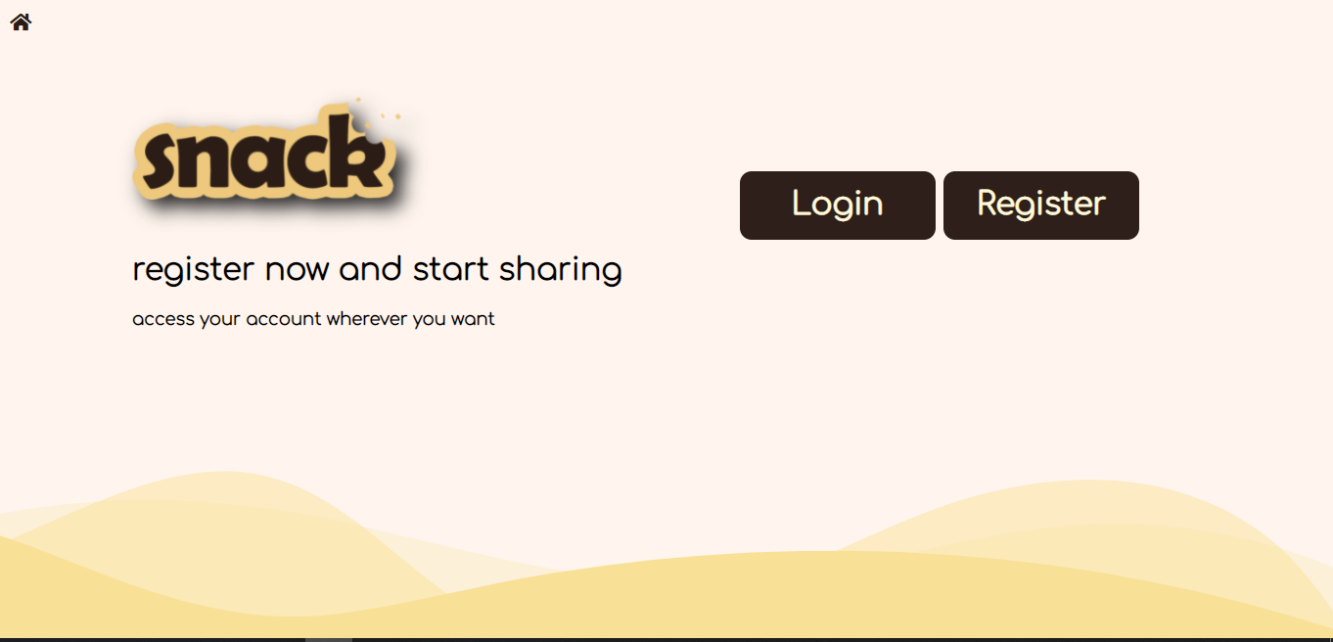

Login view,

THIS IS AN ANIMATION

PLEASE PLAY ON WORD

metin içeren bir resim

Açıklama otomatik olarak oluşturuldu

Register view,

metin içeren bir resim

Açıklama otomatik olarak oluşturuldu

THIS IS AN ANIMATION

PLEASE PLAY ON WORD



THIS IS AN ANIMATION

PLEASE PLAY ON WORD

Edit profile,



THIS IS AN ANIMATION

PLEASE PLAY ON WORD

You can change your profile photo, birth date, location as well.

metin içeren bir resim

Açıklama otomatik olarak oluşturuldu

THIS IS AN ANIMATION

PLEASE PLAY ON WORD

You can add a post which has an image, but it’s not a must to post a text.

metin içeren bir resim

Açıklama otomatik olarak oluşturuldu

THIS IS AN ANIMATION

PLEASE PLAY ON WORD

You can only edit or remove your posts, not other users. It asks you if you are sure or not before making it happen.



THIS IS AN ANIMATION

PLEASE PLAY ON WORD

Post detail view,

metin içeren bir resim

Açıklama otomatik olarak oluşturuldu

THIS IS AN ANIMATION

PLEASE PLAY ON WORD

Comment and delete comment, you can only delete your comments.

metin içeren bir resim

Açıklama otomatik olarak oluşturuldu

THIS IS AN ANIMATION

PLEASE PLAY ON WORD

metin içeren bir resim

Açıklama otomatik olarak oluşturuldu

THIS IS AN ANIMATION

PLEASE PLAY ON WORD

User search,

metin, kuş, ekran görüntüsü içeren bir resim

Açıklama otomatik olarak oluşturuldu

THIS IS AN ANIMATION

PLEASE PLAY ON WORD

You can go to a profile and view all posts of it. Also, you can “fave” that user if you are not already following. If you are, you can “unfave” that profile. You can view that profile’s followers.

metin içeren bir resim

Açıklama otomatik olarak oluşturuldu

THIS IS AN ANIMATION

PLEASE PLAY ON WORD

You can like or dislike the post but you cannot like and dislike at the same time.



THIS IS AN ANIMATION

PLEASE PLAY ON WORD

## Difficulties

Since I have never developed a database-dependent web application before, I had the most difficulty in the database part. Also, I had a hard time understanding the MVT concept that I used in my project. The MVT (Model View Template) is **a software design pattern**. It is a collection of three important components Model View and Template. The Model helps to handle database. It is a data access layer which handles the data. ... There is no separate controller and complete application is based on Model View and Template. In Django, the systems inside the website are divided into small parts and called as apps. For example, the base.html, navbar.html and index.html files that make up the website skeleton were "landing app" for me. At the very beginning, I had a hard time figuring out how to break my website into these apps. MVT concept and my apps:

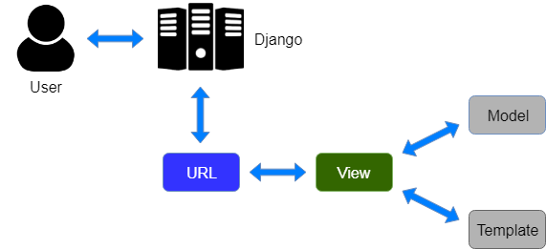

MVT Concept of Django

My apps;

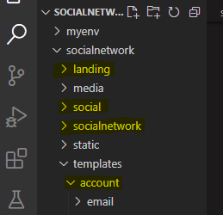

From these, social is the inside of the website which has the main functions. account app comes from allauth package.

Views.



Code structure of one of these.

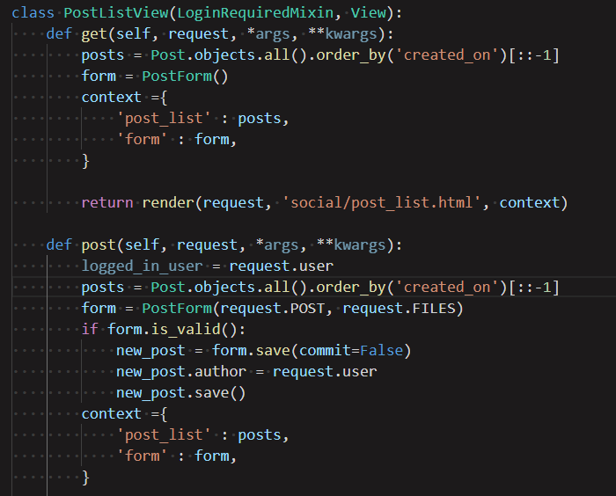

Returns the created content to a template which is under the social app

Listing post requires login operation

Templates:

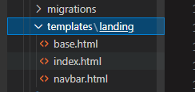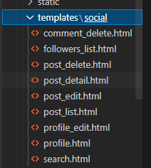

## Gains

I had no knowledge of Django and its working principle. I've never done a real database application. I learned how meticulous one must be for data filtering and web skeleton to work properly in web applications. I have basic knowledge of design languages such as HTML and CSS.

# REFERANCES

1. *Patika.dev*. (2021, 12 20). Retrieved from Orta Seviye Django ile Web Development Patikası: https://app.patika.dev/
2. Wikipedia. (2022, Ocak 11). *Wikipeda*. Retrieved from Python (programming language): [https://en.wikipedia.org/](https://en.wikipedia.org/wiki/Main_Page)
3. Wikipedia. (2022, Ocak 1). *Django (web framework)*. Retrieved from Wikipedia: https://en.wikipedia.org/
4. Miguel Araujo, D. F. (2009-2021). *django-crispy-forms*. Retrieved from Forms have never been this crispy: https://readthedocs.org/
5. Penners, R. (2017). *Welcome to django-allauth!* Retrieved from Read the Docs: https://readthedocs.org/

##### kişi, kadın, kıyafet, iç mekan içeren bir resim Açıklama otomatik olarak oluşturulduCIRRICULUM VITAE

**AYŞENUR BÜYÜKBAL**

**Personal information**

Nationality : Turkish

Place and date of birth : Ankara 03.11.1999

Marital status : Single

Foreign language : English (Upper Intermediate)

Driving license : None

**Contact information**

Phone : +90 (546) 466 57 96

E-mail : [aysenurbuyukbal@gmail.com](mailto:aysenurbuyukbal@gmail.com)

**Education**

|  |  |
| --- | --- |
| 2017 September - today | Celal Bayar University Engineering Faculty  Computer Science and Engineering Department (English) |
| 2013 September – 2017 June | Ankara Highschool (Anatolian) |

**Experience**

|  |  |
| --- | --- |
| 2021 July – 2021 August | Securify Information Technologies and Security Corporation - Ankara Teknopark |

**Skills**

Java (Good)

Python (Good)

HTML/CSS

SQL

MS Office

Adobe Photoshop (Advanced)

**Interests**

Drawing (digital drawing, charcoal), cooking, art history, cinema.